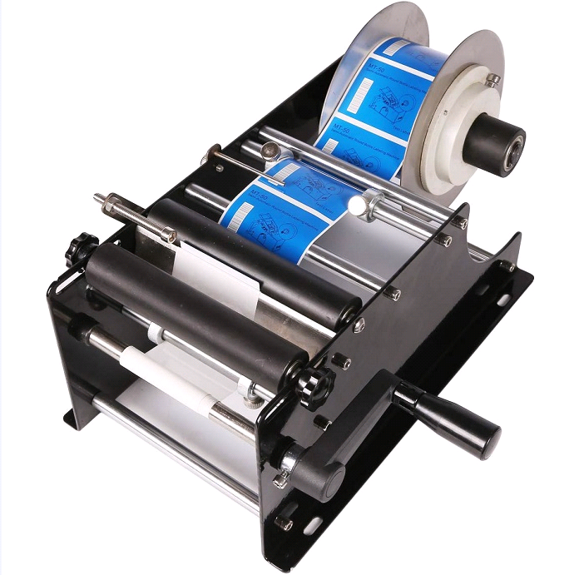

Model: DM-MRLM-30

Speed: 30 times/min

Accuracy: 0.5 mm

Label Roll inner diameter: ≥75 mm

Label Roll Out diameter: ≤190 mm

Bottle diameter:15-120mm,H≤150 mm

Label width:10-110 mm

Label Length:10-300 mm

Machine size: 400*240*210 mm

Machine weight:4.5kg

